WiFi Training Program
Assignment Questions – Module 1
- In which OSL layer the Wi-Fi standard/protocol fits.
Wi-Fi (IEEE 802.11 standards) operates primarily across the lower two layers of the OSI model: Layer 1 (Physical Layer).
Layer 1 - Physical Layer (PHY): Handles modulation, encoding, radio frequencies (2.4, 5, or 6 GHz), and transmission of raw bits over the wireless medium.
Layer 2 - Data Link Layer (DLL): Specifically the Media Access Control (MAC) sublayer, which handles frame formatting, addressing, medium arbitration, encryption (WPA2/WPA3), and error detection.
- Can you share the Wi-Fi devices that you are using day to day life, share that device's wireless capability/properties after connecting to network. Match your device to corresponding Wi-Fi Generations based on properties.
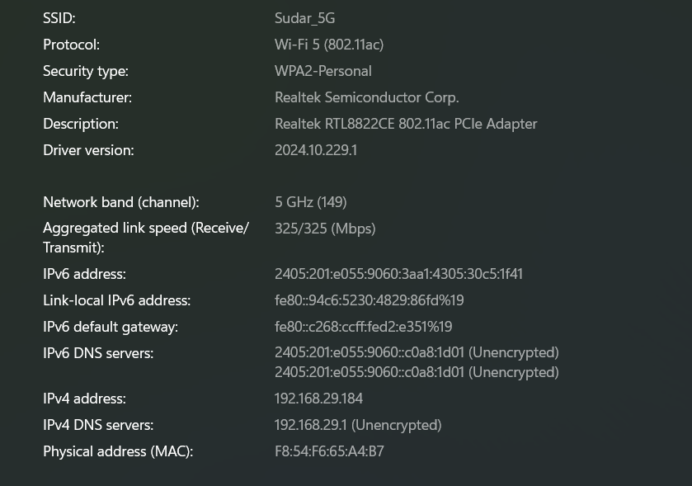

- what is BSS and ESS?

Basic Service Set (BSS) is a single, centralized wireless access point (AP) providing short-range coverage, while Extended Service Set (ESS) links multiple BSSs to extend coverage and support, creating a large, seamless network, commonly seen as multiple access points sharing the same Service set identifier.
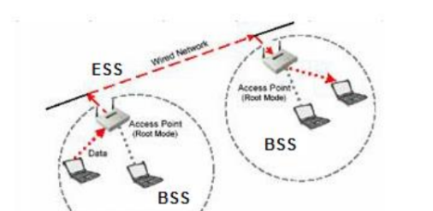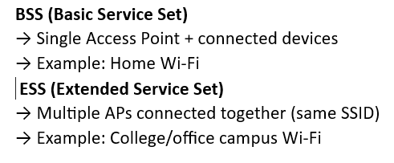

- Basic functionalities of Wi-Fi Access Point
A Wi-Fi Access Point (WAP) primarily acts as a bridge between wired Ethernet networks and wireless devices, converting wired data into wireless signals to create a Local Area Network (WLAN). Key functions include extending network coverage, allowing multiple devices to connect simultaneously, and enhancing security via encryption.

- Difference between Bridge mode and Repeater mode
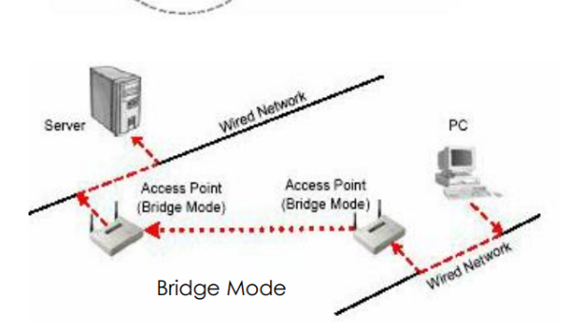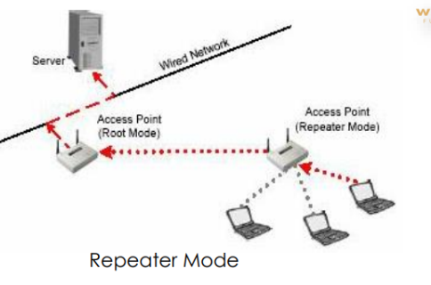
Bridge mode connects two separate network segments to act as one, acting at the data link layer to manage traffic and maintain high speeds. (eg : between two buildings).
Repeater mode amplifies an existing wireless signal to extend coverage (eg: within the same building).
- what are the differences between 802.11a and 802.11b.

Feature | 802.11a | 802.11b
Frequency | 5 GHz | 2.4 GHz
Speed | Up to 54 Mbps | Up to 11 Mbps
Range | Shorter | Longer
Interference | Less | More
Cost | Higher | Lower

- Configure your modem/hotspot to operate only in 2.4Ghz and connect your laptop/Wi-Fi device , and capture the capability/properties in your Wi-Fi device. Repeat the same in 5Ghz and tabulate all the differences you observed during this
Feature | 2.4 GHz | 5 GHz
Range | Long | Short
Speed | Lower | Higher
Interference | High | Low
Walls penetration | Better | Poor
Stability | More stable | Less stable far away

- What is the difference between IEEE and WFA
The primary difference is that IEEE (Institute of Electrical and Electronics Engineers) sets the technical, engineering standards (e.g., 802.11ax) for wireless technology, while the WFA (Wi-Fi Alliance) is a trade organization that certifies products for interoperability and markets them using user-friendly generation name.

- List down the type of Wi-Fi internet connectivity backhaul, share your home/college's wireless internet connectivity backhaul name and its properties
Wi-Fi Backhaul:
Backhaul refers to the connection between the internet service provider and the Wi-Fi router.
Types of Backhaul:
- Fiber (FTTH)
- DSL
- Cable
- Cellular (4G/5G)
- Satellite
My Home Backhaul:
The Wi-Fi network used at my home is JioFiber, which uses Fiber (FTTH) backhaul.
Properties:
- High speed (up to 100 Mbps – 1 Gbps)
- Low latency
- High reliability
- Uses optical fiber cable
10. List down the Wi-Fi topologies and use cases of each one.
Topology | Description | Use Case
Infrastructure mode | AP-based network | Home, office
Ad-hoc | Device-to-device | File sharing
Mesh | Multiple APs interconnected | Large campus
Point-to-Point | Direct link between 2 nodes | Building-to-building

